

**Dr. D.Y. Patil School of MCA**

**Charoli (BK), PUNE-** **412105**

**SAVITRIBAI PHULE PUNE UNIVERSITY**

**MASTER OF COMPUTER APPLICATION**

Project Report on

“Multi Utility App”

Under The Guidance Of

“Prof. Rajnish Mishra”

**BY**

**Suraj Shinde (1951)**

**Class: MCA-II (Sem-III)**

**Year: 2023-202****4**



DR. D.Y. Patil School of MCA Charholi (Bk), Lohegaon, Pune – 412105

Certificate

This is to certify that Mr. Suraj Shinde (1951) Student of the class MCA-II (Sem-III) has successfully completed the Mini Project entitled “ **Multi Utility App** “during the academic year 2023-2024

**Prof. Rajnish Mishra Prof. Santosh Deshmukh Dr. E. B. Khedkar**

**Project Guide HOD Director**

**Examiner 1 Examiner 2**

**Place :** Pune

**Date :**

**Index**

|  |  |  |
| --- | --- | --- |
| **Sr. No.** | **CHAPTER DETAILS** | **Page Number** |
| **1** | **INTRODUCTION** |  |
| 1.1 | INTRODUCTION |  |
| 1.2 | LIMITATION OF EXISTING SYSTEM |  |
| 1.3 | NEED FOR THE PROPOSED SYSTEM |  |
| **2** | **PROPOSED SYSTEM** |  |
| 2.1 | PROBLEM STATEMENT |  |
| 2.2 | OBJECTIVES OF THE PROPOSED SYSTEM |  |
| 2.3 | FUNCTIONAL REQUIREMENTS |  |
| 2.4 | NON-FUNCTIONAL REQUIREMENTS |  |
| 2.5 | SCOPE OF THE SYSTEM |  |
| 2.6 | MODULE SPECIFICATIONS |  |
| 2.7 | OPERATING ENVIRONMENT |  |
| **3** | **REQUIREMENT DETERMINATION AND ANALYSIS** |  |
| 3.1 | FACT FINDING METHOD |  |
| 3.2 | FEASIBILITY STUDY |  |
| **4** | **SYSTEM ANALYSIS AND DESIGN** |  |
| 4.1 | USE CASE DIAGRAM |  |
| 4.2 | ACTIVITY DIAGRAM |  |
| 4.3 | SEQUENCE DIAGRAM |  |
| 4.4 | CLASS DIAGRAM |  |
| 4.5 | ENTITY RELATIONSHIP DIAGRAM |  |
| 4.6 | TABLE SPECIFICATION |  |
| 4.7 | USER INTERFACE SCREENS |  |
| **5** | **TEST CASES** |  |
| **6** | **DRAWBACKS AND LIMITATION** |  |
| **7** | **PROPOSED ENHANCEMENT** |  |
| **8** | **CONCLUSION** |  |
| **9** | **BIBLIOGRAPHY** |  |
| **10** | **ANNEXURES** |  |
| **11** | **SAMPLE CODE** |  |

1. **Introduction**
   1. **Introduction**

In today's fast-paced world, managing multiple applications for basic tasks can be inconvenient. The need for a unified platform that integrates essential utilities like a calculator, note-taking, and currency conversion has never been more critical. Our project aims to address this issue by developing a Multi-Utility Android App, streamlining the user experience and enhancing efficiency. In an era where simplicity and efficiency are paramount, our project endeavors to create a Multi-Utility Android App, offering a unified platform for essential tasks. This app integrates a calculator, notes functionality, and a currency converter, eliminating the hassle of managing multiple applications.

* 1. **Limitation of Existing System**

The existing system, comprising separate applications for a calculator, notes, and currency conversion, is not without its limitations. One significant drawback is the lack of integration, forcing users to switch between multiple apps to perform seemingly straightforward tasks. This disjointed experience leads to inefficiency and a potential decrease in user productivity. Additionally, the separate nature of these applications may result in a fragmented user interface, making it challenging for users to maintain a consistent and coherent digital workflow. Another limitation lies in the absence of a unified platform for data storage and retrieval, particularly in the case of notes. Users may find it cumbersome to manage notes across different applications, leading to a potential loss of organization and accessibility.

* 1. **Need of the Proposed system**

The need for the proposed Multi-Utility Android App is rooted in the recognition of the challenges and inconveniences faced by users when managing multiple applications for basic tasks. With the current proliferation of diverse utilities like calculators, note-taking apps, and currency converters, users often find themselves navigating through a plethora of interfaces, leading to a disjointed and time-consuming experience. The proposed system aims to fill this gap by providing a comprehensive solution that amalgamates these essential functionalities within a single, cohesive platform. The need for such a system is underscored by the desire to simplify users' digital interactions and enhance their overall efficiency. By consolidating the calculator, notes, and currency converter into one unified app, the proposed system aims to streamline tasks, reduce cognitive load, and offer users a more seamless and intuitive experience. Additionally, the system responds to the growing demand for versatile mobile applications that cater to various user needs, providing a one-stop solution for everyday tasks.

1. **Proposed System**
   1. **Problem Statement**

The problem addressed by this project arises from the inefficiencies and inconveniences associated with managing multiple applications for fundamental tasks on mobile devices. Users currently grapple with the hassle of navigating through distinct apps for functions like calculations, note-taking, and currency conversion. This fragmented experience not only consumes valuable time but also hinders productivity as users constantly switch between different interfaces. The lack of integration results in a disjointed workflow, creating a significant user pain point. Additionally, maintaining data and information across separate applications, especially in the case of notes, poses challenges in terms of organization and accessibility. Recognizing these issues, the project aims to tackle the fundamental problem of a disjointed digital experience by proposing a Multi-Utility Android App.

* 1. **Objectives of the proposed system**
* Simplify users' digital interactions by providing a unified platform for essential utilities.
* Enhance user productivity by offering a single app for common tasks like calculations, note-taking, and currency conversion.
* Improve user experience through an intuitive interface and seamless integration of diverse functionalities.
* Ensure data security and privacy in the notes feature, addressing users' concerns about sensitive information.
* Foster adaptability and future expansion by designing a modular system that can accommodate additional utilities.
  1. **Functional Requirements**
* Implement a calculator module supporting basic and scientific operations.
* Develop a notes functionality allowing users to create, edit, and categorize notes.
* Integrate a currency converter providing real-time exchange rates for multiple currencies.
* Include a unit converter for common measurements like length, weight, and temperature.
* Implement offline functionality for essential features, ensuring usability without an internet connection.
  1. **Non-Functional Requirements**
* Ensure a responsive and user-friendly interface for seamless navigation.
* Implement robust data security measures, particularly for the notes feature.
* Optimize app performance to ensure quick and efficient execution of tasks.
* Support cross-device compatibility for various Android devices and screen sizes.
* Provide regular updates to enhance features, address issues, and ensure long-term usability.
  1. **Scope of system**
     + **Integrated Utilities:** The app will include a calculator, notes functionality, and a currency converter, allowing users to perform essential tasks without switching between multiple applications.
     + **User Interface:** The user interface will be intuitive, ensuring ease of navigation and seamless interaction with each utility.
     + **Future Expansion:** The system will be designed to accommodate future expansions, allowing the addition of more utilities or features based on user feedback and emerging technologies.
     + **Calculator Features:** Basic arithmetic operations (addition, subtraction, multiplication, division).
     + **Notes Functionality:** Creation, editing, and deletion of notes.
     + **Currency Converter Features:** Support for multiple currencies, allowing users to convert between various international currencies.
     + **Cross-Device Compatibility:** Compatibility with various Android devices, ensuring the app functions smoothly across different screen sizes and resolutions.
  2. **Module Specification**
* Calculator Module
* Currency Converter Module
* Calendar Module
* To-do-List Module
  1. **Operating System**

**Hardware Configuration**

* **Processor**: Intel core i5
* **Ram** : 8 GB
* **Hard-Disk**: 10 GB

**Software Configuration :**

* + **Front-End**: XML (Extensible Markup Language)
  + **Backend**: Java
  + **Database** : SQLite
  + **Operating System:** Windows 7 and above
  + **Ide** : Android Studio

1. **Requirement Determination & Analysis**
   1. **Fact Finding Method**

* **Interviews:** Conduct interviews with potential users to gather insights into their expectations, preferences, and pain points related to existing utility applications.
* **Surveys and Questionnaires:** Create and distribute surveys or questionnaires to a targeted audience to collect quantitative and qualitative data on user needs and preferences.
* **Observation:** Observe users in their natural environment, if possible, to understand their current behaviors and identify areas where a multi-utility app could streamline their tasks.
* **Prototyping and Feedback:** Develop prototypes or wireframes of the app's interface and functionalities and gather feedback from potential users to understand their reactions and preferences.
* **Focus Groups:** Organize focus group sessions to facilitate discussions among potential users, allowing you to explore their opinions, expectations, and suggestions.
* **Feedback from Beta Testing:** If applicable, release beta versions of your app to a select group of users and gather feedback on their experiences and any issues encountered.
* **Use of Analytics Tools:** Utilize analytics tools to gather data on user interactions within the app, helping you understand usage patterns and areas for improvement.
  1. **Feasibility Study**
* **Technical Feasibility:** Evaluate the availability of required technologies, tools, and expertise for developing the Multi-Utility Android App.
* **Operational Feasibility:** Assess the practicality of integrating multiple utilities into a single app and its compatibility with users' daily routines.
* **Economic Feasibility:** Analyze the project's cost-effectiveness, considering development, maintenance, and potential revenue models.
* **Scalability Feasibility:** Examine the scalability of the proposed system to accommodate potential future expansions and additional functionalities.
* **User Acceptance Feasibility:** Gauge potential user acceptance through surveys and feedback to ensure the proposed system meets user expectations.
* **Risk Analysis:** Identify potential risks and challenges related to development, implementation, and user adoption.
* **Time Feasibility:** Assess the project timeline and deadlines to ensure the timely delivery of the Multi-Utility Android App.

1. **System Analysis & Design**
2. 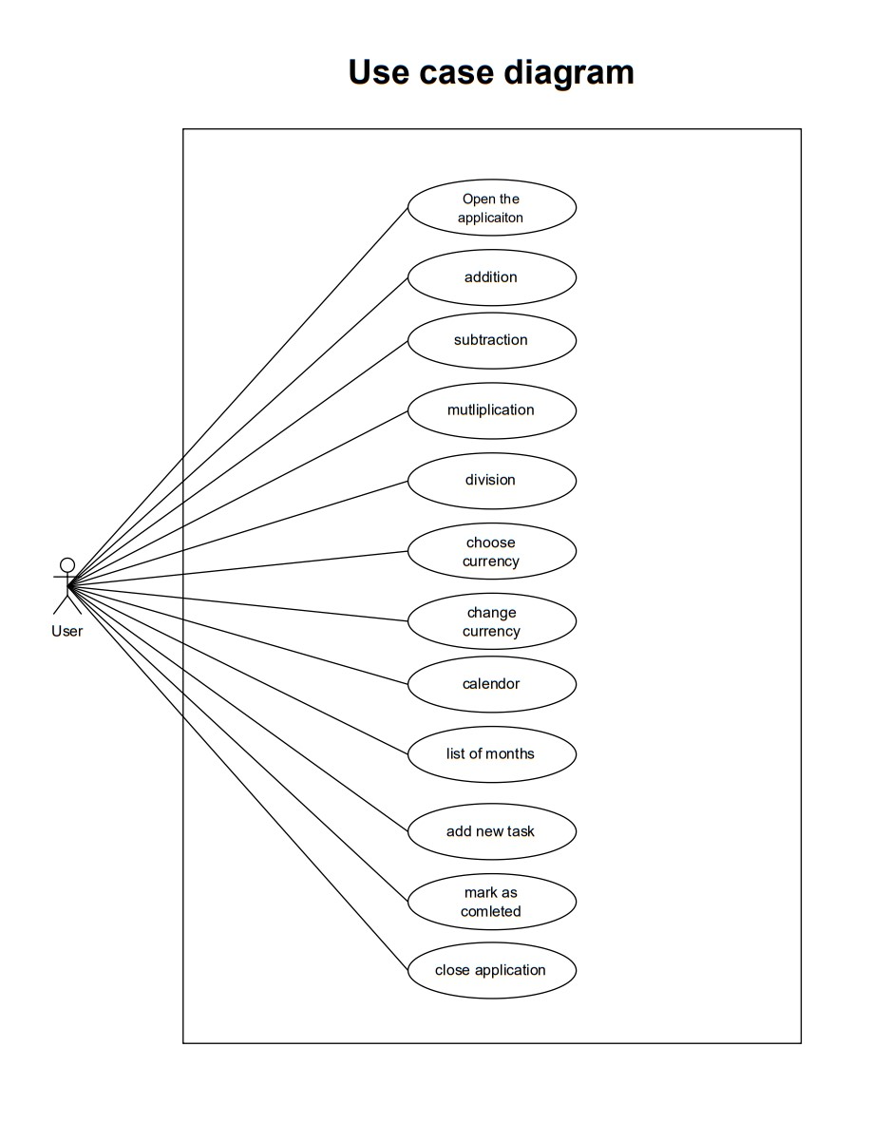
   1. **Use Case Diagram**
   2. 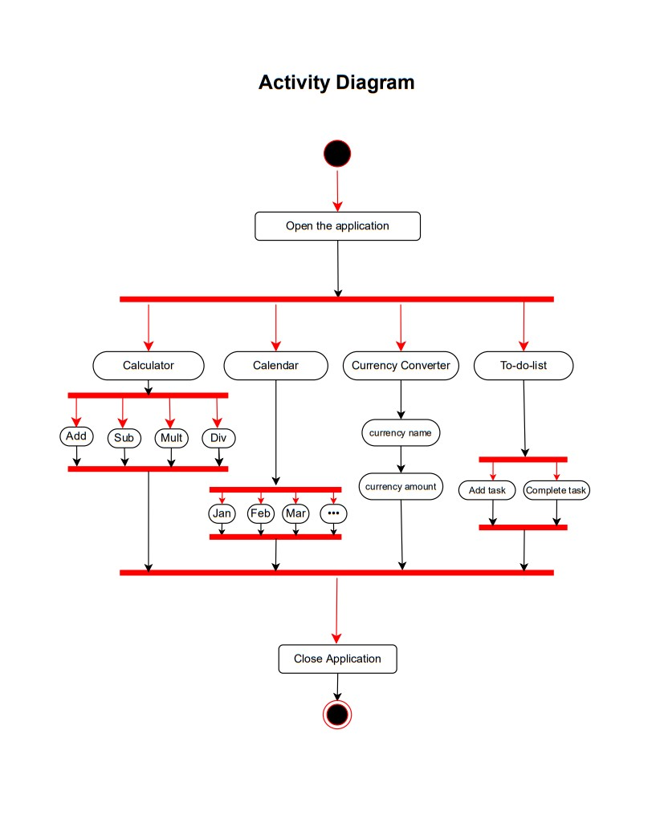**Activity Diagram**
   3. **Sequence Diagram**

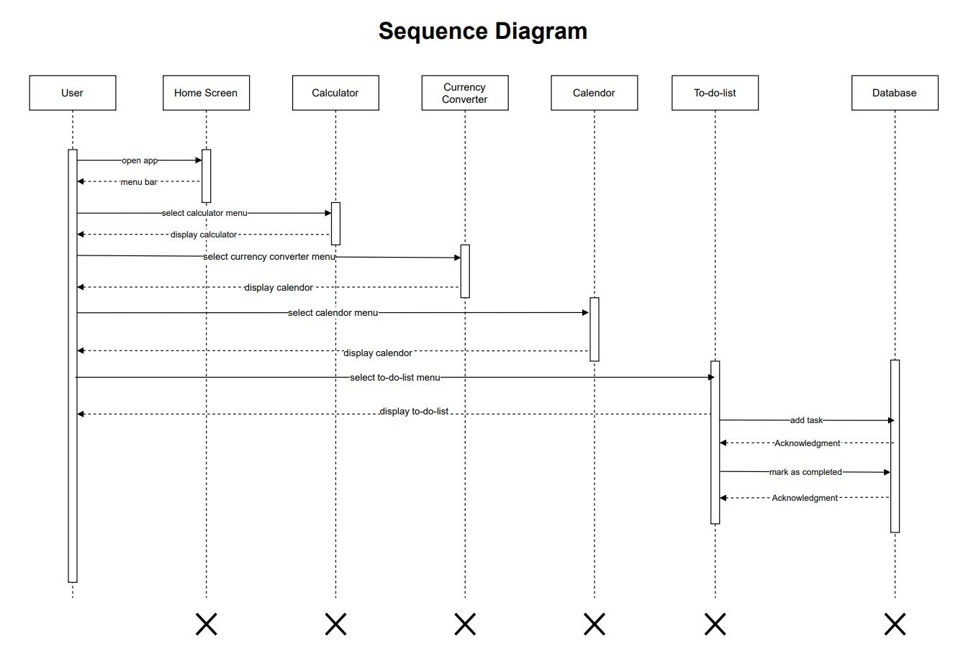

* 1. **Class Diagram**

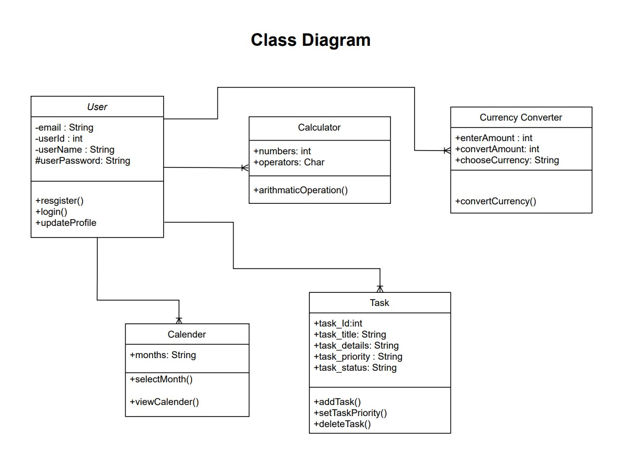

* 1. **Entity Relationship Diagram**

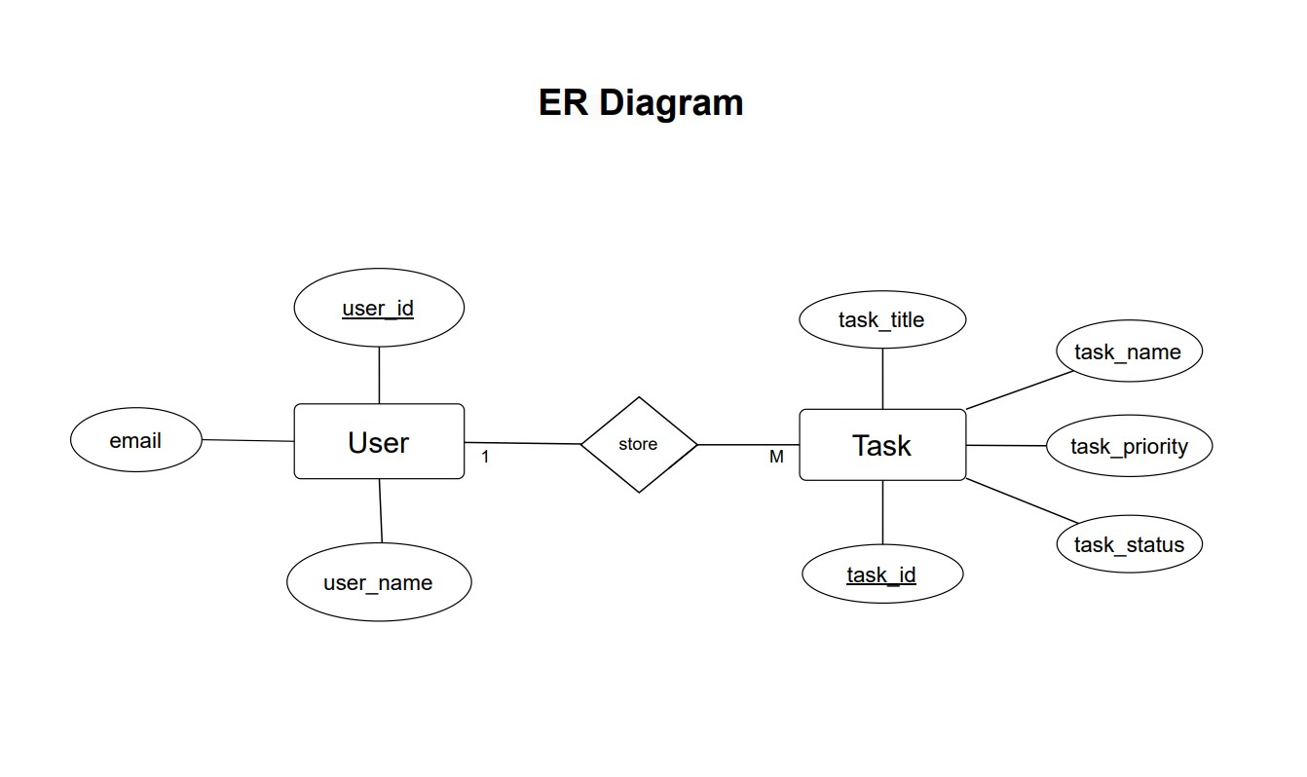

* 1. **Table Specification**
* **Table Name: task_table**

This table is used to store details about the task details

|  |  |  |  |  |  |
| --- | --- | --- | --- | --- | --- |
| **Sr. No** | **Field** | **Data Type** | **Size** | **Constraint** | **Description** |
| 1. | task_id | int | 11 | PRIMARY KEY | Task Id |
| 2. | task_title | text | 20 | NOT NULL | Task Title |
| 3. | due_date | date | 50 |  | Due date of task |
| 4. | task_details | text | 100 | NOT NULL | Details about Task |
| 5. | task_priority | text | 10 |  | Priority of Task |
| 6. | completion_status | text | 20 |  | Completion status of Task |

* 1. **User Interface Design**

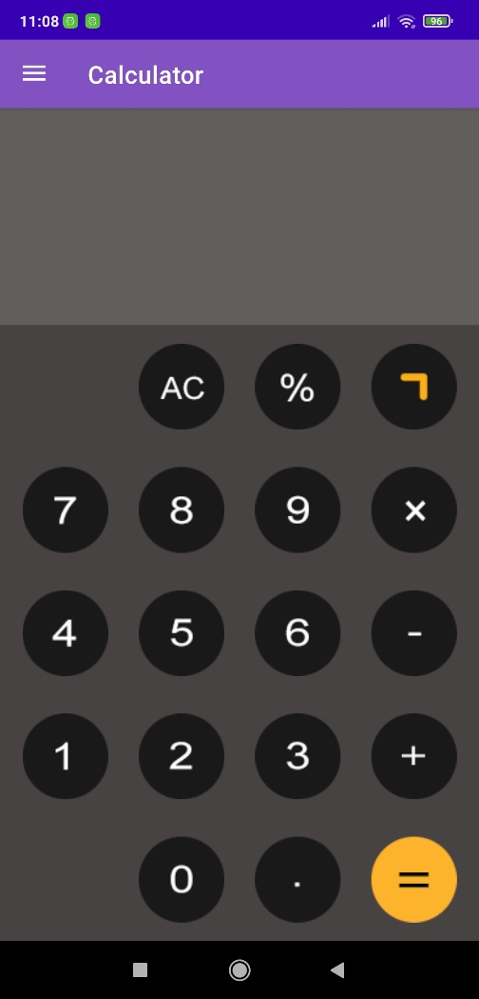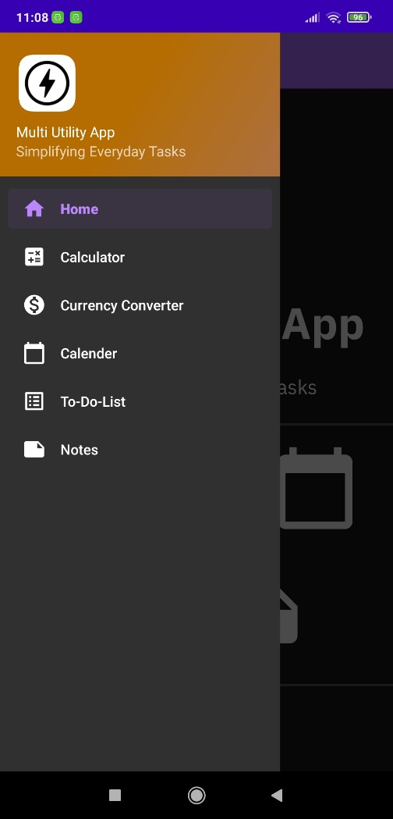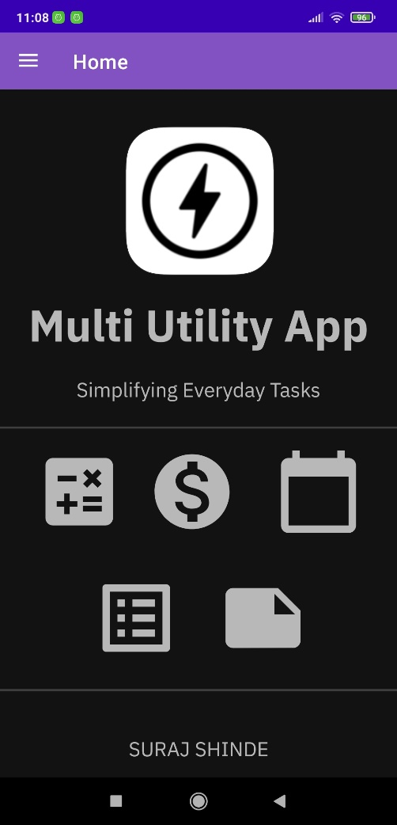

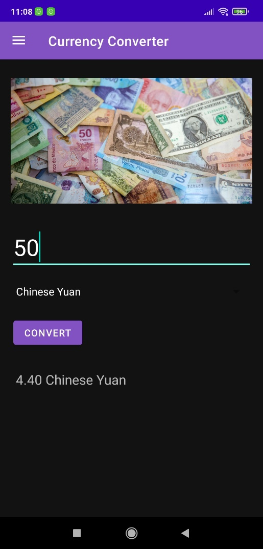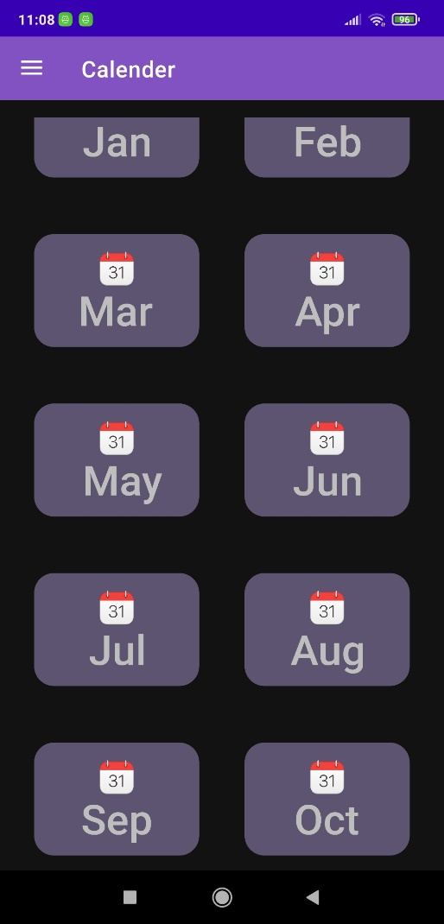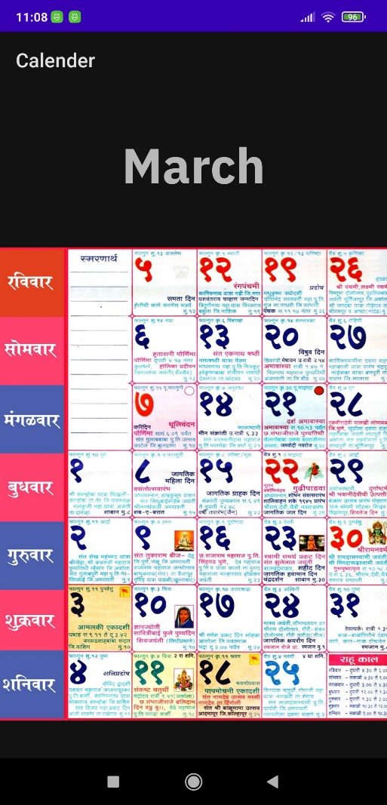

1. **Test Cases**

|  |  |  |  |  |  |
| --- | --- | --- | --- | --- | --- |
| **Test Id** | **Description** | **Test Case Input** | **Expected Result** | **Actual Result** | **Test Case Status** |
| TC01 | Open the application | Click on application | Home Screen should be open | Home screen is not open | Fail |
| TC02 | Open the application | Click on application | Home Screen should be open | Home screen is open | Pass |
| TC03 | Side bar show in home screen | - | Side bar should be show in home screen | Side bar is not show in home screen | Fail |
| TC04 | Side bar show in home screen | - | Side bar should be show in home screen | Side bar is show in home screen | Pass |
| TC05 | List of modules show in side bar | Click on side bar | List of modules should be show in side bar | List of modules not show in side bar | Fail |
| TC06 | List of modules show in side bar | Click on side bar | List of modules should be show in side bar | List of modules show in side bar | Pass |
| TC07 | Open calculator module | Click on calculator module | Calculator should be open | Calculator is not open | Fail |
| TC08 | Open calculator module | Click on calculator module | Calculator should be open | Calculator is open | Pass |
| TC09 | Open Currency converter module | Click on currency converter module | Currency converter should be open | Currency converter is not open | Fail |
| TC10 | Open Currency converter module | Click on currency converter module | Currency converter should be open | Currency converter is open | Pass |
| TC11 | Open Calendar module | Click on calendar module | calendar should be open | calendar is not open | Fail |
| TC12 | Open Calendar module | Click on calendar module | calendar should be open | calendar is open | Pass |
| TC13 | Open To-do-list module | Click on to-do-list module | To-do-list should be open | To-do-list is not open | Fail |
| TC14 | Open To-do-list module | Click on to-do-list module | To-do-list should be open | To-do-list is open | Pass |
| TC15 | Enter Amount | Amount = -120 | Amount should be entered | Amount is not less than 1 | Fail |
| TC16 | Enter Amount | Amount = 0 | Amount should be entered | Amount is not equal to 0 | Fail |
| TC17 | Enter Amount | Amount = 60 | Amount should be entered | Amount is entered | Pass |
| TC18 | Select currency name | Null | Currency name should be selected | Currency name is not selected | Fail |
| TC19 | Select currency name | Currency name = USD | Currency name should be selected | Currency name is selected | Pass |
| TC20 | Select January month | Click on January month | January Month calendar should be open | Calendar is not open of January | Fail |
| TC21 | Select January month | Click on January month | January Month calendar should be open | Calendar is open of January | Pass |
| TC22 | Select February month | Click on February month | February Month calendar should be open | Calendar is not open of February | Fail |
| TC23 | Select February month | Click on February month | February Month calendar should be open | Calendar is open of February | Pass |
| TC24 | Select March month | Click on March month | March Month calendar should be open | Calendar is not open of March | Fail |
| TC25 | Select March month | Click on March month | March Month calendar should be open | Calendar is open of March | Pass |

1. **Drawbacks and Limitation**

* **Limited Initial Features:**

The initial release may lack certain advanced features due to time constraints, potentially limiting its functionality.

* **Dependency on External APIs:**

The reliance on external APIs for real-time data, such as currency exchange rates, may introduce potential issues if the external services experience downtime or changes.

* **Device Compatibility Challenges:**

Ensuring seamless performance across a wide range of Android devices may pose challenges due to variations in screen sizes, resolutions, and hardware capabilities.

* **Offline Functionality Constraints:**

The offline functionality, while essential, may have limitations in terms of the range of features available without an internet connection.

* **Security Considerations:**

Implementing robust security measures for the notes feature is crucial, and any lapses may compromise user data.

* **User Learning Curve:**

Introducing a unified app for multiple utilities might require users to adapt to a new interface, potentially leading to a learning curve.

* **Continuous Maintenance Requirements:**

Ongoing maintenance will be necessary to address emerging issues, update external APIs, and ensure compatibility with evolving Android versions.

* **Resource Intensiveness:**

Depending on the features and functionalities implemented, the app may consume significant device resources, affecting performance on lower-end devices.

1. **Proposed Enhancement**

* **Multi-Language Support:**

Integrate language options for a broader user base, allowing users to interact with the app in their preferred language.

* **Additional Utility Modules:**

Explore the addition of new utility modules, such as a unit converter or a task scheduler, to further expand the app's functionality.

* **Cloud Integration for Notes:**

Implement cloud integration for notes, enabling users to sync and access their notes across multiple devices securely.

* **Advanced Calculator Functions:**

Introduce advanced calculator functions like graphing capabilities or a customizable formula library for users with more complex mathematical needs.

* **Collaborative Notes:**

Enable collaborative note-taking, allowing multiple users to edit and contribute to shared notes in real-time.

* **Intuitive Voice Commands:**

Incorporate voice command functionality for hands-free operation, particularly useful for users on the go.

* **Smart Notifications:**

Implement intelligent notifications, providing timely reminders based on users' notes or scheduled tasks.

1. **Conclusion**

In conclusion, the development of the Multi-Utility Android App represents a significant stride towards addressing the challenges associated with fragmented digital experiences. By amalgamating essential utilities such as a calculator, notes, and currency converter into a single, cohesive platform, this project aims to simplify and enrich users' daily interactions with their mobile devices. The user-centric design prioritizes efficiency and convenience, offering a seamless and intuitive interface. As the app unfolds, it not only provides a solution to the current inconveniences users face but also anticipates future needs. The project's modular architecture and commitment to user feedback position it as a dynamic and adaptable tool, ready to evolve with emerging technologies and user expectations. Through the integration of diverse functionalities and a continuous focus on user experience, the Multi-Utility Android App aspires to be a versatile and indispensable companion, streamlining tasks and enhancing productivity in the ever-evolving digital landscape.

1. **Bibliography**

* **www.Google.com**
* **www.youtube.com**
* **www.javatpoint.com**
* **www.stackoverflow.com**
* **www.w3schools.com**
* **https://developer.android.com/**
* **https://chat.openai.com/**

1. **Annexures**

* **User Interface Design Mockups:**

Detailed visual representations of the app's user interface, including design mockups for each utility module (calculator, notes, currency converter).

* **Technical Architecture Diagrams:**

Visual representations of the technical architecture, illustrating the system's components, interactions, and data flow.

* **Survey Questionnaire:**

The detailed questionnaire used for user surveys, containing questions related to user preferences, expectations, and feedback.

* **Source Code Snippets:**

Selected snippets of source code highlighting key functionalities or innovative features implemented in the app.

* **Test Cases and Results:**

A comprehensive set of test cases used during the development process, along with the corresponding results and any adjustments made based on testing outcomes.

* **User Feedback and Iterations:**

A log of user feedback received during various stages of development, along with documented iterations made to address user concerns or enhance features.

1. **Sample Code**

<?xml version="1.0" encoding="utf-8"?>  
<RelativeLayout xmlns:android="http://schemas.android.com/apk/res/android"  
 xmlns:app="http://schemas.android.com/apk/res-auto"  
 xmlns:tools="http://schemas.android.com/tools"  
 android:layout_width="match_parent"  
 android:layout_height="match_parent"  
 android:background="#AEA9A9"  
 tools:context=".ui.calculator.CalculatorFragment">  
  
  
 <TextView  
 android:id="@+id/inputTxt"  
 android:layout_width="match_parent"  
 android:layout_height="wrap_content"  
 android:layout_above="@id/outPuttxt"  
 android:gravity="right"  
 android:paddingRight="20dp"  
 android:textColor="#535353"  
 android:textSize="40dp" />  
  
  
 <TextView  
 android:id="@+id/outPuttxt"  
 android:layout_width="match_parent"  
 android:layout_height="wrap_content"  
 android:layout_above="@id/buttons"  
 android:gravity="right"  
 android:paddingRight="20dp"  
 android:textColor="@color/black"  
 android:textSize="90dp" />  
  
  
 <LinearLayout  
 android:id="@+id/buttons"  
 android:layout_width="match_parent"  
 android:layout_height="wrap_content"  
 android:layout_alignParentBottom="true"  
 android:background="#CDC7C7"  
 android:orientation="vertical">  
  
 <LinearLayout  
 android:layout_width="match_parent"  
 android:layout_height="wrap_content"  
 android:layout_marginTop="10dp"  
 android:layout_marginBottom="10dp"  
 android:gravity="center"  
 android:orientation="horizontal"  
 android:paddingTop="5dp"  
 android:paddingBottom="5dp">  
  
 <ImageView  
 android:layout_width="70dp"  
 android:layout_height="70dp"  
 android:layout_marginStart="25dp"  
 android:layout_marginLeft="25dp"  
 android:layout_marginEnd="25dp"  
 android:layout_marginRight="25dp"  
 android:background="@drawable/btn_1"  
 android:visibility="invisible" />  
  
 <ImageView  
 android:id="@+id/btn_ac"  
 android:layout_width="70dp"  
 android:layout_height="70dp"  
 android:layout_marginRight="25dp"  
 android:background="@drawable/btn_ac" />  
  
 <ImageView  
 android:id="@+id/btn_module"  
 android:layout_width="70dp"  
 android:layout_height="70dp"  
 android:layout_marginRight="25dp"  
 android:background="@drawable/btn_module" />  
  
 <ImageView  
  
 android:layout_width="70dp"  
 android:layout_height="70dp"  
 android:layout_marginRight="25dp"  
 android:background="@drawable/btn_extra" />  
  
 </LinearLayout>  
  
 <LinearLayout  
 android:layout_width="match_parent"  
 android:layout_height="wrap_content"  
 android:layout_marginTop="10dp"  
 android:layout_marginBottom="10dp"  
 android:gravity="center"  
 android:orientation="horizontal"  
 android:paddingTop="5dp"  
 android:paddingBottom="5dp">  
  
 <ImageView  
 android:id="@+id/btn_7"  
 android:layout_width="70dp"  
 android:layout_height="70dp"  
 android:layout_marginStart="25dp"  
 android:layout_marginLeft="25dp"  
 android:layout_marginEnd="25dp"  
 android:layout_marginRight="25dp"  
 android:background="@drawable/btn_7" />  
  
 <ImageView  
 android:id="@+id/btn_8"  
 android:layout_width="70dp"  
 android:layout_height="70dp"  
 android:layout_marginRight="25dp"  
 android:background="@drawable/btn_8" />  
  
 <ImageView  
 android:id="@+id/btn_9"  
 android:layout_width="70dp"  
 android:layout_height="70dp"  
 android:layout_marginRight="25dp"  
 android:background="@drawable/btn_9" />  
  
 <ImageView  
 android:id="@+id/btn_multiplication"  
 android:layout_width="70dp"  
 android:layout_height="70dp"  
 android:layout_marginRight="25dp"  
 android:background="@drawable/btn_multiplication" />  
  
 </LinearLayout>  
  
 <LinearLayout  
 android:layout_width="match_parent"  
 android:layout_height="wrap_content"  
 android:layout_marginTop="10dp"  
 android:layout_marginBottom="10dp"  
 android:gravity="center"  
 android:orientation="horizontal"  
 android:paddingTop="5dp"  
 android:paddingBottom="5dp">  
  
  
 <ImageView  
 android:id="@+id/btn_4"  
 android:layout_width="70dp"  
 android:layout_height="70dp"  
 android:layout_marginStart="25dp"  
 android:layout_marginLeft="25dp"  
 android:layout_marginEnd="25dp"  
 android:layout_marginRight="25dp"  
 android:background="@drawable/btn_4" />  
  
 <ImageView  
 android:id="@+id/btn_5"  
 android:layout_width="70dp"  
 android:layout_height="70dp"  
 android:layout_marginRight="25dp"  
 android:background="@drawable/btn_5" />  
  
 <ImageView  
 android:id="@+id/btn_6"  
 android:layout_width="70dp"  
 android:layout_height="70dp"  
 android:layout_marginRight="25dp"  
 android:background="@drawable/btn_6" />  
  
 <ImageView  
 android:id="@+id/btn_minus"  
 android:layout_width="70dp"  
 android:layout_height="70dp"  
 android:layout_marginRight="25dp"  
 android:background="@drawable/btn_minus" />  
  
 </LinearLayout>  
  
 <LinearLayout  
 android:layout_width="match_parent"  
 android:layout_height="wrap_content"  
 android:layout_marginTop="10dp"  
 android:layout_marginBottom="10dp"  
 android:gravity="center"  
 android:orientation="horizontal"  
 android:paddingTop="5dp"  
 android:paddingBottom="5dp">  
  
 <ImageView  
 android:id="@+id/btn_1"  
 android:layout_width="70dp"  
 android:layout_height="70dp"  
 android:layout_marginStart="25dp"  
 android:layout_marginLeft="25dp"  
 android:layout_marginEnd="25dp"  
 android:layout_marginRight="25dp"  
 android:background="@drawable/btn_1" />  
  
 <ImageView  
 android:id="@+id/btn_2"  
 android:layout_width="70dp"  
 android:layout_height="70dp"  
 android:layout_marginRight="25dp"  
 android:background="@drawable/btn_2" />  
  
 <ImageView  
 android:id="@+id/btn_3"  
 android:layout_width="70dp"  
 android:layout_height="70dp"  
 android:layout_marginRight="25dp"  
 android:background="@drawable/btn_3" />  
  
 <ImageView  
 android:id="@+id/btn_plus"  
 android:layout_width="70dp"  
 android:layout_height="70dp"  
 android:layout_marginRight="25dp"  
 android:background="@drawable/btn_plus" />  
  
 </LinearLayout>  
  
 <LinearLayout  
 android:layout_width="match_parent"  
 android:layout_height="wrap_content"  
 android:layout_marginTop="10dp"  
 android:layout_marginBottom="10dp"  
 android:gravity="center"  
 android:orientation="horizontal"  
 android:paddingTop="5dp"  
 android:paddingBottom="5dp">  
  
 <ImageView  
 android:layout_width="70dp"  
 android:layout_height="70dp"  
 android:layout_marginStart="25dp"  
 android:layout_marginLeft="25dp"  
 android:layout_marginEnd="25dp"  
 android:layout_marginRight="25dp"  
 android:background="@drawable/btn_1"  
 android:visibility="invisible" />  
  
 <ImageView  
 android:id="@+id/btn_0"  
 android:layout_width="70dp"  
 android:layout_height="70dp"  
 android:layout_marginRight="25dp"  
 android:background="@drawable/btn_0" />  
  
 <ImageView  
 android:id="@+id/btn_dot"  
 android:layout_width="70dp"  
 android:layout_height="70dp"  
 android:layout_marginRight="25dp"  
 android:background="@drawable/btn_dot" />  
  
 <ImageView  
 android:id="@+id/btn_equal"  
 android:layout_width="70dp"  
 android:layout_height="70dp"  
 android:layout_marginRight="25dp"  
 android:background="@drawable/btn_equal" />  
  
 </LinearLayout>  
  
  
 </LinearLayout>  
  
  
</RelativeLayout>

package com.example.multiutilityapp.ui.calculator;  
  
  
import android.annotation.SuppressLint;  
import android.os.Bundle;  
import android.view.LayoutInflater;  
import android.view.View;  
import android.view.ViewGroup;  
import android.widget.ImageView;  
import android.widget.TextView;  
  
import androidx.annotation.NonNull;  
import androidx.annotation.Nullable;  
import androidx.fragment.app.Fragment;  
  
import com.example.multiutilityapp.R;  
  
import org.mozilla.javascript.Context;  
import org.mozilla.javascript.Script;  
import org.mozilla.javascript.Scriptable;  
  
public class CalculatorFragment extends Fragment{  
 ImageView btn_1, btn_2, btn_3, btn_4, btn_5, btn_6, btn_7, btn_8, btn_9, btn_0;  
 ImageView btn_dot, btn_equal, btn_ac, btn_module, btn_plus, btn_minus, btn_multiplication;  
  
 TextView inputTxt, outPuttxt;  
  
 String data;  
  
 @SuppressLint("MissingInflatedId")  
 @Override  
 public View onCreateView(@NonNull LayoutInflater inflater, @Nullable ViewGroup container,  
 @Nullable Bundle savedInstanceState) {  
 View view = inflater.inflate(R.layout.fragment_calculator, container, false);  
  
 outPuttxt = view.findViewById(R.id.outPuttxt);  
 inputTxt = view.findViewById(R.id.inputTxt);  
  
 btn_0 = view.findViewById(R.id.btn_0);  
 btn_1 = view.findViewById(R.id.btn_1);  
 btn_2 = view.findViewById(R.id.btn_2);  
 btn_3 = view.findViewById(R.id.btn_3);  
 btn_4 = view.findViewById(R.id.btn_4);  
 btn_5 = view.findViewById(R.id.btn_5);  
 btn_6 = view.findViewById(R.id.btn_6);  
 btn_7 = view.findViewById(R.id.btn_7);  
 btn_8 = view.findViewById(R.id.btn_8);  
 btn_9 = view.findViewById(R.id.btn_9);  
  
 btn_dot = view.findViewById(R.id.btn_dot);  
 btn_equal = view.findViewById(R.id.btn_equal);  
 btn_ac = view.findViewById(R.id.btn_ac);  
 btn_module = view.findViewById(R.id.btn_module);  
 btn_plus = view.findViewById(R.id.btn_plus);  
 btn_minus = view.findViewById(R.id.btn_minus);  
 btn_multiplication = view.findViewById(R.id.btn_multiplication);  
  
 suraj();  
 return view;  
 //inflater.inflate(R.layout.fragment_calculator, container, false)  
 }  
  
  
 public void suraj() {  
  
 btn_0.setOnClickListener(new View.OnClickListener() {  
 @Override  
 public void onClick(View v) {  
 data = inputTxt.getText().toString();  
 inputTxt.setText(data + "0");  
 }  
 });  
  
 btn_1.setOnClickListener(new View.OnClickListener() {  
 @Override  
 public void onClick(View v) {  
 data = inputTxt.getText().toString();  
 inputTxt.setText(data + "1");  
 }  
 });  
  
 btn_2.setOnClickListener(new View.OnClickListener() {  
 @Override  
 public void onClick(View v) {  
 data = inputTxt.getText().toString();  
 inputTxt.setText(data + "2");  
 }  
 });  
  
  
 btn_3.setOnClickListener(new View.OnClickListener() {  
 @Override  
 public void onClick(View v) {  
 data = inputTxt.getText().toString();  
 inputTxt.setText(data + "3");  
 }  
 });  
  
 btn_4.setOnClickListener(new View.OnClickListener() {  
 @Override  
 public void onClick(View v) {  
 data = inputTxt.getText().toString();  
 inputTxt.setText(data + "4");  
 }  
 });  
  
 btn_5.setOnClickListener(new View.OnClickListener() {  
 @Override  
 public void onClick(View v) {  
 data = inputTxt.getText().toString();  
 inputTxt.setText(data + "5");  
 }  
 });  
  
 btn_6.setOnClickListener(new View.OnClickListener() {  
 @Override  
 public void onClick(View v) {  
 data = inputTxt.getText().toString();  
 inputTxt.setText(data + "6");  
 }  
 });  
  
 btn_7.setOnClickListener(new View.OnClickListener() {  
 @Override  
 public void onClick(View v) {  
 data = inputTxt.getText().toString();  
 inputTxt.setText(data + "7");  
 }  
 });  
  
 btn_8.setOnClickListener(new View.OnClickListener() {  
 @Override  
 public void onClick(View v) {  
 data = inputTxt.getText().toString();  
 inputTxt.setText(data + "8");  
 }  
 });  
  
 btn_9.setOnClickListener(new View.OnClickListener() {  
 @Override  
 public void onClick(View v) {  
 data = inputTxt.getText().toString();  
 inputTxt.setText(data + "9");  
 }  
 });  
  
 btn_ac.setOnClickListener(new View.OnClickListener() {  
 @Override  
 public void onClick(View v) {  
 inputTxt.setText("");  
 outPuttxt.setText("");  
 }  
 });  
  
 btn_dot.setOnClickListener(new View.OnClickListener() {  
 @Override  
 public void onClick(View v) {  
 data = inputTxt.getText().toString();  
 inputTxt.setText(data + ".");  
 }  
 });  
  
 btn_plus.setOnClickListener(new View.OnClickListener() {  
 @Override  
 public void onClick(View v) {  
 data = inputTxt.getText().toString();  
 inputTxt.setText(data + "+");  
 }  
 });  
  
 btn_minus.setOnClickListener(new View.OnClickListener() {  
 @Override  
 public void onClick(View v) {  
 data = inputTxt.getText().toString();  
 inputTxt.setText(data + "-");  
 }  
 });  
  
 btn_module.setOnClickListener(new View.OnClickListener() {  
 @Override  
 public void onClick(View v) {  
 data = inputTxt.getText().toString();  
 inputTxt.setText(data + "%");  
 }  
 });  
  
 btn_multiplication.setOnClickListener(new View.OnClickListener() {  
 @Override  
 public void onClick(View v) {  
 data = inputTxt.getText().toString();  
 inputTxt.setText(data + "×");  
 }  
 });  
  
 btn_equal.setOnClickListener(new View.OnClickListener() {  
 @Override  
 public void onClick(View v) {  
 data = inputTxt.getText().toString();  
  
 data=data.replaceAll("×","*");  
 data=data.replaceAll("%","/100");  
 data=data.replaceAll("÷","/");  
  
 Context rhino = Context.enter();  
 rhino.setOptimizationLevel(-1);  
  
 String finalResult="";  
  
 Scriptable scriptable=rhino.initStandardObjects();  
 finalResult=rhino.evaluateString(scriptable,data,"Javsscript",1,null).toString();  
  
 outPuttxt.setText(finalResult);  
  
 }  
 });  
  
 }  
}